Explain the advantages of Natural Queries in PowerBi with an example?

In the dashboard, there is a search bar that says Ask a question about your data. You can find insights that might not exist in your report but exist in your model based on the measures you've already created. It's important to build your model well for instances like these.

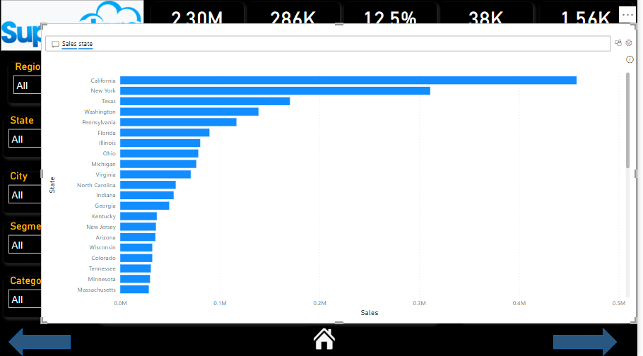

**Explain Web Front End(WFE) cluster from Power BI Service Architecture?**

**The WFE cluster manages the initial connection and authentication to the Power BI service**, and once authenticated, the Back-End handles all subsequent user interactions

Explain Back End cluster from Power BI Service Architecture?

The Back-End cluster manages visualizations, user dashboards, datasets, reports, data storage, data connections, data refresh, and other aspects of interacting with the Power BI service.

What ASP.NET component does in Power BI Service Architecture?

A WFE cluster consists of an ASP.NET website running in the Azure app Service When users attempt to connect to the Power BI service, the client's DNS service may communicate with the Azure Traffic Manager to find the most appropriate datacenter with a Power BI deployment.

Compare Microsoft Excel and PowerBi Desktop on the following features:

1. Data import - Excel has limitations in the amount of data it can work with. In contrast, Power BI can handle much larger amounts of data. Power BI can connect to a large number of data sources, while Excel's connectivity capacity is limited.
2. Data transformation - Power BI has faster processing than Excel. Power BI dashboards are more visually appealing, interactive and customizable than those in Excel. Power BI is a more powerful tool than Excel in terms of comparison between tables, reports or data files.
3. Modeling - Excel is mainly used for simple analysis tasks on historical data only while Power BI deals with the simplification of real-time data obtained from disparate sources, apart from complex analysis of historical data.
4. Reporting - Excel offers you a limited range of dashboards if you look at interactivity and the range of functions. It has a tabular data format that can help you visualize data with various chart formats. Power BI has a cohort of powerful features like easy formatting, natural language querying, resizing, editing, and filtering that make the reports easy to understand, and visually attractive, while helping you draw multi-faceted insights to guide the decision-making process
5. Server Deployment – Excel is a tool in which you can connect data, clean, and shape data, create reports with your data**. But compare to power Bi excel is not more efficient.Power BI Desktop** is a tool in which you can connect data, transform, and shape data, create reports with your data. It is a free application and installs on a local computer. The desktop allows you to connect to different types of data sources and then transform it in a data model. And publish the Power BI reports to either on the **Power BI Service** or on the **Power Bi Report Server.**
6. Convert Models - Excel is used to organize data, transform it and perform mathematical operations and calculations. On the other hand, Power BI was conceived as a business intelligence and data visualization tool for businesses. Excel has limitations in the amount of data it can work with.
7. Cost – The Cost of Excel is starting $6 per month and the cost of Power Bi is starting $9.99 per month.

List 20 data sources supported by Power Bi desktop.

1. Microsoft Excel
2. Text CSV
3. XML
4. Json
5. Pdf
6. Parquet
7. Share Point Folder
8. Sql server Database
9. Access Database
10. Sql server analysis service database
11. Oracle Database
12. IBM Db2 Database
13. IBM Infomix Database (Beta)
14. IBM Netezza
15. My Sql Database
16. Sybase Database
17. Amazon Redshift
18. Impala
19. Google Big query
20. Snowflake